Seedling & Plant Sale
THURSDAY & FRIDAY, MARCH 1st & 2nd
BUNCOMBE SWCD
49 Mount Carmel Road
Asheville, NC 28806
(828) 250-4785
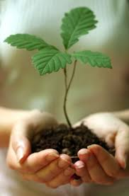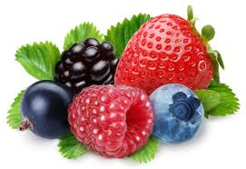
Seedlings 18” – 24” | Plants
Eastern Redbud $2.00 | Blackberry – Thornless Prime Ark $3.00
White Dogwood $2.00 | Raspberry – Caroline $3.00
River Birch $2.00 | Blueberry – Blue Crop $6.00
Elderberry $2.00 | Blueberry – Duke $6.00
Persimmon $2.00 | Strawberry – Sweet Charlie $0.50 or 25/$10.00
Bartlett Pear $2.00 | Strawberry – Winter Dawn $0.50 or 25/$10.00
Seedlings 24” – 48” | Strawberry – Festival $0.50 or 25/$10.00
Gala Apple $8.00
Golden Delicious $8.00
Brown Turkey Fig $8.00

8AM – 5PM OR UNTIL SOLD OUT
LIMITED QUANTITIES – COME EARLY FOR BEST SELECTION!

